EXPERIMENT 9

Name: Arav Desai | Roll No: 3
Subject: Programming and problem solving | Class/Batch: AIML A
Date of Performance: 14/8/2024 | Date of Submission:

Code

- Write a program to accept „n‟ integers from user into an array and display them
#include <stdio.h>

int main() {
int n;

printf("Enter the number of integers: ");
scanf("%d", &n);

int arr[n];

printf("Enter %d integers:\n", n);
for (int i = 0; i < n; i++) {
scanf("%d", &arr[i]);
}

printf("The integers you entered are:\n");
for (int i = 0; i < n; i++) {
printf("%d ", arr[i]);
}

printf("\n");

return 0;
}
Output
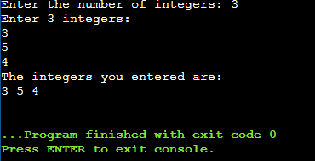

Code
II. Write a program to accept „n‟ integers from user into an array and display the sum of these numbers.
#include <stdio.h>

int main() {
int n, sum = 0;

printf("Enter the number of integers: ");
scanf("%d", &n);

int arr[n];

printf("Enter %d integers:\n", n);
for (int i = 0; i < n; i++) {
scanf("%d", &arr[i]);
sum += arr[i]; // Add each number to the sum
}

printf("The sum of the integers is: %d\n", sum);

return 0;
}
Output

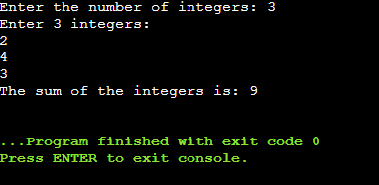
Code

III. Write a program to search an element in an array and display the index of the element.
#include <stdio.h>

int main() {
int n, searchElement, found = 0;

printf("Enter the number of integers: ");
scanf("%d", &n);

int arr[n];

printf("Enter %d integers:\n", n);
for (int i = 0; i < n; i++) {
scanf("%d", &arr[i]);
}

printf("Enter the element to search: ");
scanf("%d", &searchElement);

for (int i = 0; i < n; i++) {
if (arr[i] == searchElement) {
printf("Element %d found at index: %d\n", searchElement, i);
found = 1;
break;
}
}

if (!found) {
printf("Element %d not found in the array.\n", searchElement);
}

return 0;
}
Output

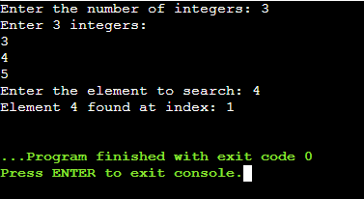

Code

IV. Write a program to sort numbers in ascending order. (implement bubble sorting algorithm )
#include <stdio.h>

void bubbleSort(int arr[], int n) {
for (int i = 0; i < n-1; i++) {
for (int j = 0; j < n-i-1; j++) {
if (arr[j] > arr[j+1]) {
// Swap arr[j] and arr[j+1]
int temp = arr[j];
arr[j] = arr[j+1];
arr[j+1] = temp;
}
}
}
}

int main() {
int n;

printf("Enter the number of integers: ");
scanf("%d", &n);

int arr[n];

printf("Enter %d integers:\n", n);
for (int i = 0; i < n; i++) {
scanf("%d", &arr[i]);
}

// Sorting the array
bubbleSort(arr, n);

printf("Sorted array in ascending order:\n");
for (int i = 0; i < n; i++) {
printf("%d ", arr[i]);
}

printf("\n");

return 0;
}

Output

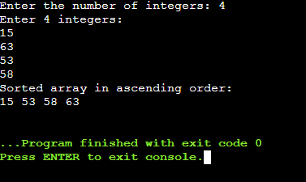

Code

V. Write a program to accept the two dimensional matrix and display the original matrix and its transpose.
#include <stdio.h>

int main() {
int rows, columns;

printf("Enter the number of rows: ");
scanf("%d", &rows);

printf("Enter the number of columns: ");
scanf("%d", &columns);

int matrix[rows][columns];
int transpose[columns][rows];

printf("Enter the elements of the matrix:\n");
for (int i = 0; i < rows; i++) {
for (int j = 0; j < columns; j++) {
scanf("%d", &matrix[i][j]);
}
}

// Display the original matrix
printf("Original Matrix:\n");
for (int i = 0; i < rows; i++) {
for (int j = 0; j < columns; j++) {
printf("%d ", matrix[i][j]);
}
printf("\n");
}

// Compute the transpose of the matrix
for (int i = 0; i < rows; i++) {
for (int j = 0; j < columns; j++) {
transpose[j][i] = matrix[i][j];
}
}

// Display the transpose of the matrix
printf("Transpose of the Matrix:\n");
for (int i = 0; i < columns; i++) {
for (int j = 0; j < rows; j++) {
printf("%d ", transpose[i][j]);
}
printf("\n");
}

return 0;
}

Output

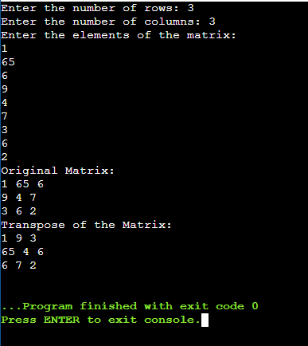

Code

VI. Write a program to accept the two dimensional matrix A and B and perform their addition.
#include <stdio.h>

int main() {
int rows, columns;

printf("Enter the number of rows: ");
scanf("%d", &rows);

printf("Enter the number of columns: ");
scanf("%d", &columns);

int matrixA[rows][columns], matrixB[rows][columns], result[rows][columns];

printf("Enter elements of matrix A:\n");
for (int i = 0; i < rows; i++) {
for (int j = 0; j < columns; j++) {
scanf("%d", &matrixA[i][j]);
}
}

printf("Enter elements of matrix B:\n");
for (int i = 0; i < rows; i++) {
for (int j = 0; j < columns; j++) {
scanf("%d", &matrixB[i][j]);
}
}

// Perform matrix addition
for (int i = 0; i < rows; i++) {
for (int j = 0; j < columns; j++) {
result[i][j] = matrixA[i][j] + matrixB[i][j];
}
}

// Display the result
printf("Resultant Matrix after addition:\n");
for (int i = 0; i < rows; i++) {
for (int j = 0; j < columns; j++) {
printf("%d ", result[i][j]);
}
printf("\n");
}

return 0;
}
Output

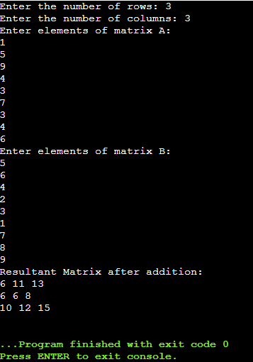

Code
VII. Check whether string is palindrome or not
#include <stdio.h>
#include <string.h>
#include <stdbool.h>

// Function prototype
bool isPalindrome(char str[]);

int main() {
char str[100];

printf("Enter a string: ");
gets(str); // Using gets() for simplicity, but it's unsafe. Prefer fgets() in real applications.

if (isPalindrome(str)) {
printf("The string \"%s\" is a palindrome.\n", str);
} else {
printf("The string \"%s\" is not a palindrome.\n", str);
}

return 0;
}

// Function definition
bool isPalindrome(char str[]) {
int length = strlen(str);
for (int i = 0; i < length / 2; i++) {
if (str[i] != str[length - i - 1]) {
return false;
}
}
return true;
}
Output
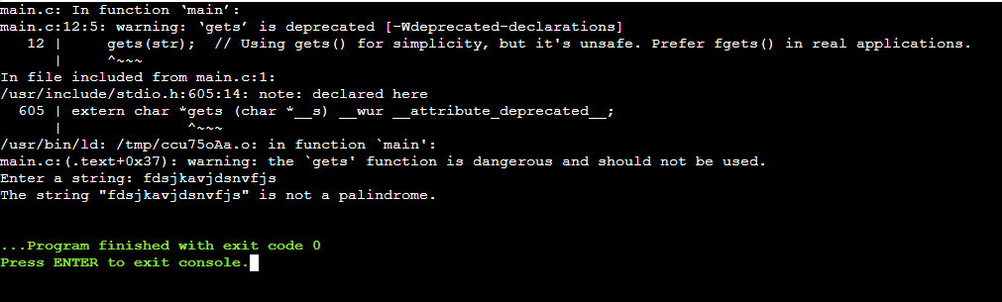
Code
VIII. Write a program to carry out following operations on strings using library functions. (a) To concatenate a string S2 to string S1. (b) To find the length of a given string. (c) To compare two strings S1 and S2. (d) To copy a string S2 to another string S1
#include <stdio.h>
#include <string.h>

int main() {
char str1[100], str2[100];
int result;

// Input strings
printf("Enter the first string (S1): ");
gets(str1); // Using gets() for simplicity, but it's unsafe. Prefer fgets() in real applications.

printf("Enter the second string (S2): ");
gets(str2);

// (a) Concatenate str2 to str1
strcat(str1, str2);
printf("After concatenation, S1: %s\n", str1);

// (b) Find the length of a given string
printf("Length of the string S1: %ld\n", strlen(str1));

// (c) Compare two strings S1 and S2
result = strcmp(str1, str2);
if (result == 0) {
printf("Strings S1 and S2 are equal.\n");
} else if (result < 0) {
printf("String S1 is less than string S2.\n");
} else {
printf("String S1 is greater than string S2.\n");
}

// (d) Copy string S2 to another string S1
strcpy(str1, str2);
printf("After copying, S1: %s\n", str1);

return 0;
}
Output
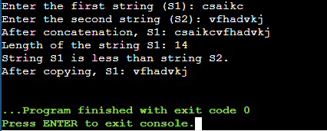
Conclusion

In conclusion, the recent programming exercises have provided an excellent opportunity to explore a wide range of fundamental concepts and techniques in C. We've delved into working with arrays, matrix operations, string manipulations, and more. From accepting and displaying integers, performing matrix addition and transposition, to checking for palindromes and implementing sorting algorithms, these programs have not only reinforced our understanding of C syntax but also demonstrated the practical applications of various data structures and algorithms. These exercises have laid a solid foundation for further learning and development in programming, showcasing the power and versatility of the C language in solving diverse computational problems. This journey has equipped us with valuable skills and insights, preparing us for more complex challenges and advanced programming endeavors in the future.

Assessment

Timely Submission  (7) | Presentation  (06) | Understanding  (12) | Total  (25) | Sign

